Spring Security Default Username, Password, Role

Create a Simple Spring Boot Project

I assume you already have your Spring Boot project created but if you do not, here is a very short tutorial on creating a simple Spring Boot project with Spring Initializr.

Add Spring Security

To add Spring Security to your Spring Boot project, open the pom.xml file and add the following dependency:

<dependency>

<groupId>org.springframework.boot</groupId>

<artifactId>spring-boot-starter-security</artifactId>

</dependency>

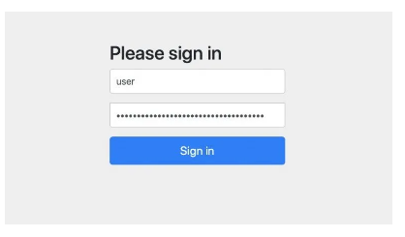

The default username is: user and the default password will be printed in the console at the time when your Spring Boot project starts.



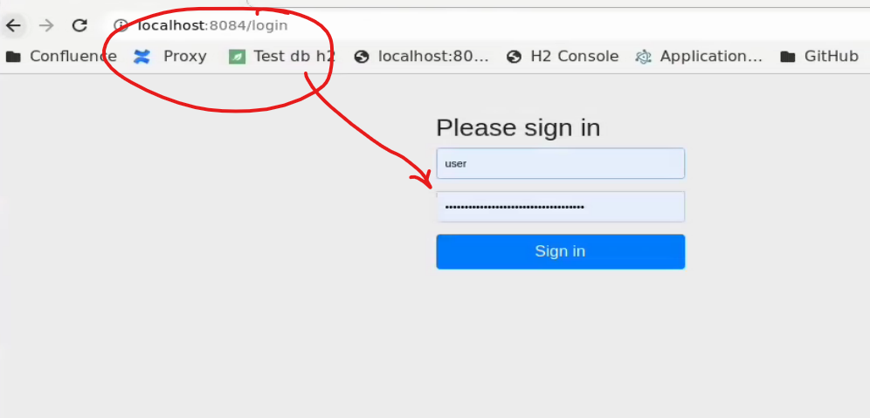

Configure Default Username, Password and Role

To configure the default username, password and role, open application.properties file of your Spring Boot project and add the following three properties with the values you prefer.

spring.security.user.name=sergey

spring.security.user.password=sergey

spring.security.user.roles=manager

The above properties will change the default username, password and role. Restart your Spring Boot project and try the new username and password you have set. Also, once you have set a custom password for the default user, you will notice that a default Spring Security password is no longer generated and printed in the

The above properties will change the default username, password and role. Restart your Spring Boot project and try the new username and password you have set. Also, once you have set a custom password for the default user, you will notice that a default Spring Security password is no longer generated and printed in the console.

Secure Specific URLs

You can secure specific URLs of your application and make them accessible by users of a specific Role only. For example, in the application.properties file above, we have configured the Role of a default user to be a manager. Let’s now configure access for a specific URL in our application so that only a user with the role “manager” can access it.

In your Spring Boot project, create a new Java class and:

Annotate it with @EnableWebSecurity annotation,

Annotation class with @Configuration annotation,

Implement the configure(HttpSecurity http) method like in the example below;

import org.springframework.security.config.annotation.web.builders.HttpSecurity;

import org.springframework.security.config.annotation.web.configuration.EnableWebSecurity;

import org.springframework.context.annotation.Bean;

import org.springframework.context.annotation.Configuration;

import org.springframework.security.web.SecurityFilterChain;

@Configuration

@EnableWebSecurity

public class WebSecurity{

@Bean

public SecurityFilterChain configure(HttpSecurity http) throws Exception {

http

.cors().and()

.csrf().disable().authorizeHttpRequests()

.requestMatchers("/users").hasRole("manager")

.anyRequest().authenticated()

.and()

.formLogin();

return http.build();

}

}

